**Title:**

**Responsive Design - To create a responsive web page (continue)**

**Objective(s):**

At the end of these lessons, students will be able to.

* Create a responsive web page using fluid grid layout

**Tools, Equipment and Materials:**

1. Personal Computer with Internet access
2. Web Authoring Tool (Adobe Dreamweaver CC)
3. Web Browser
4. Lab Material: Asset Folder

**Instructions:**

**Part (A) – Define a site**

1. Launch Dreamweaver CC and choose Site > New Site.
2. In the Site Setup dialog box, type fluidLayouts2 in the Site Name field.
3. Click the folder icon next to the Local Site Folder field.
4. In the Choose Root Folder dialog box, navigate to the fluidLayouts2 folder on your desktop.
5. Click **Save** to close the Site Setup dialog box.

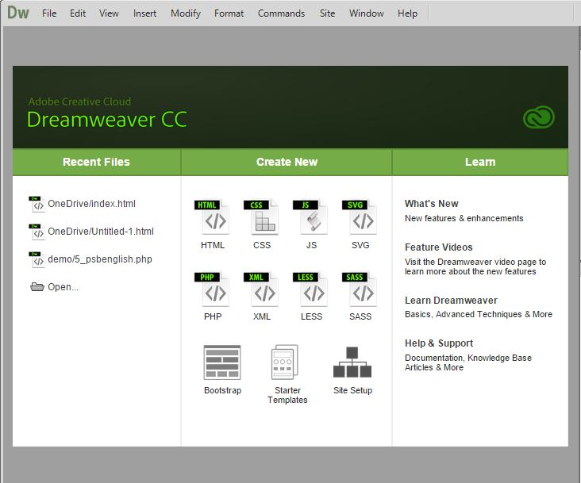

**Part(B) Copy Asset files**

1. Copy the given asset files into the folder:

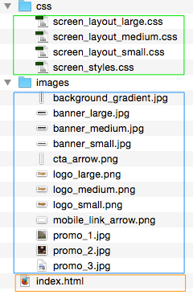

**Create the HTML5 structure**

1. In Dreamweaver > File Windows: click on refresh and then double click on index.html:

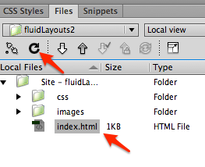

1. Code view: Add the DIV and HTML 5 structures:

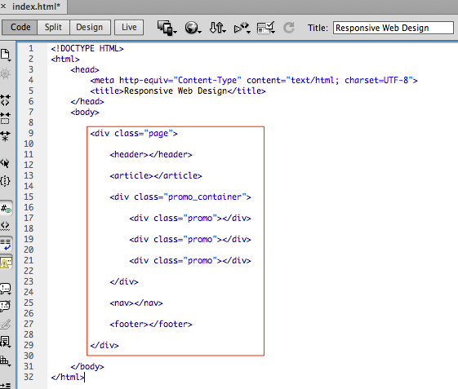

**Add content**

1. Add the Logo anchor tags, the navigation links and the footer text:

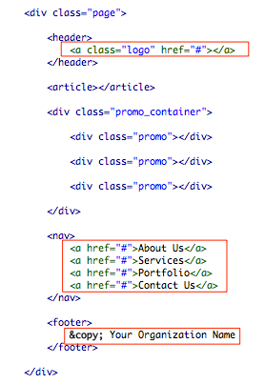

1. Dreamweaver: Open the given “A-Placeholder-Text.html” file from the asset “Do not copy – text” folder:

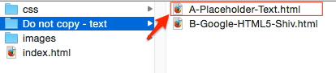

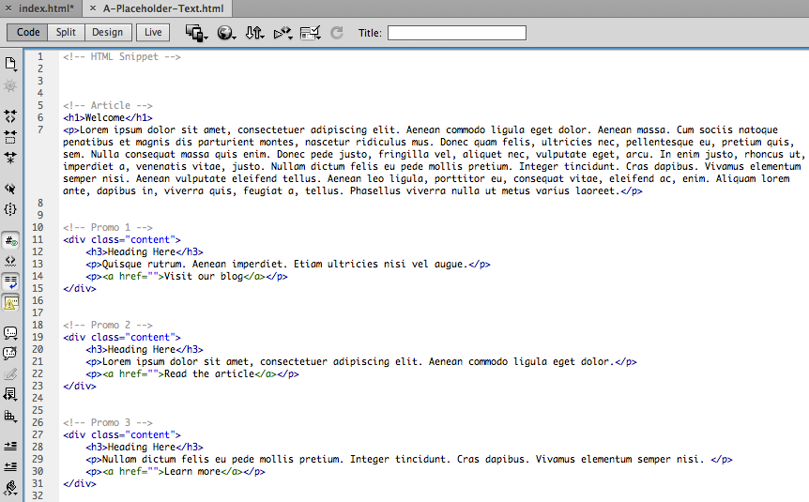

1. Copy and paste the following placeholder texts into index.html:

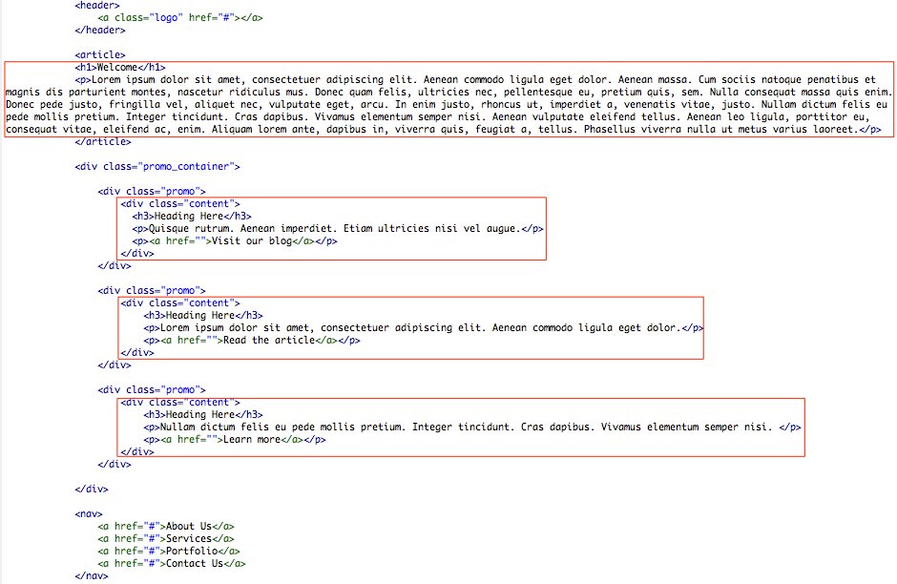

1. Save and Preview in a browser:

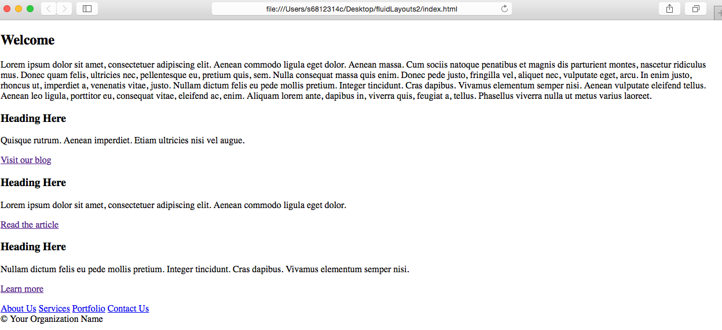

**Add CSS and media rules**

1. Add the following CSS files and media rules:

<link rel="stylesheet" type="text/css" href="css/screen_styles.css" />

<link rel="stylesheet" type="text/css" href="css/screen_layout_large.css" />

<link rel="stylesheet" type="text/css" media="only screen and (min-width:50px) and (max-width:500px)" href="css/screen_layout_small.css" />

<link rel="stylesheet" type="text/css" media="only screen and (min-width:501px) and (max-width:800px)" href="css/screen_layout_medium.css" />

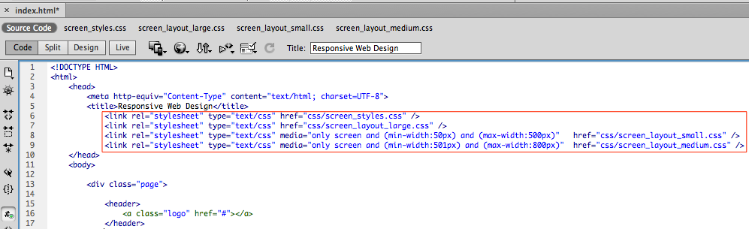

1. Confirm that the files are linked correctly by clicking on the four css files links next to “Source Code”:

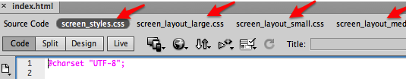

**Prevent scaling in mobile devices’ viewport**

|  |  |
| --- | --- |
| Scaled viewport | Non-scaled viewport |
|  |  |

Mobile devices have default behaviour of scaling the page as shown above unless instruction is given not to do so.

1. Add viewport instruction as follows:

<meta name=viewport content="width=device-width, initial-scale=1" />

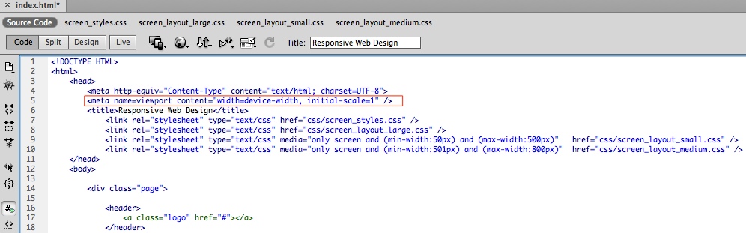

**Add common styles (screen_styles.css)**

1. Screen_styles.css - Add the following styles for body and .page:

body {

color: #575c7a; /* dark grey */

line-height: 1.5em;

font-family: Arial;

font-size: 14px;

/* background-color background-image background-repeat background-position */

background: #515673 url(../images/background_gradient.jpg) repeat-x 0px 0px;

}

.page {

max-width: 980px;

margin: 0px auto;

position: relative; background-color: #fff;

}

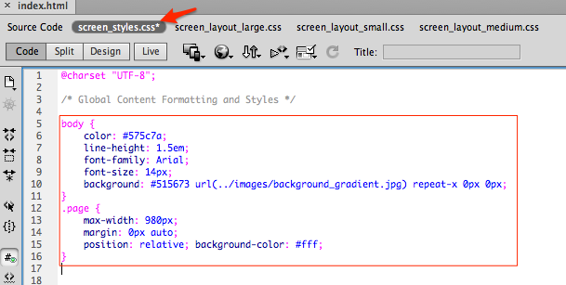

1. Save and preview on a browser.

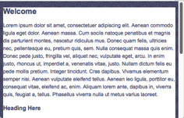 (Narrow view) => (Wide view)

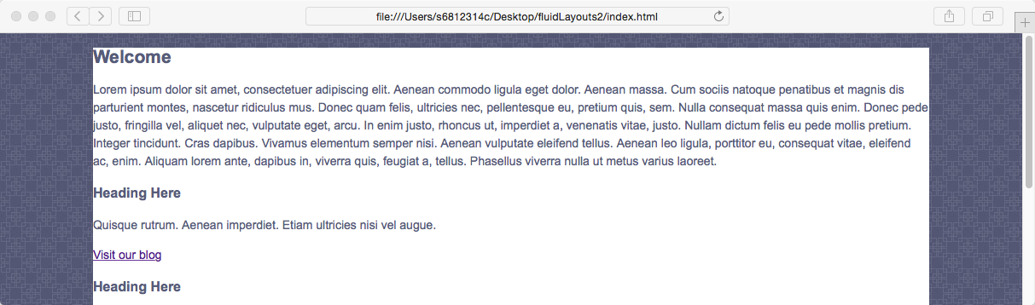

1. Screen_styles.css - Add the following styles for header h1 to h3:

h1 { color: #a6430a; margin: 0em 0em .5em 0em; font-size: 2em; font-weight: normal; }

h2 { font-size: 1.7em; margin: 0em 0em 1em 0em; }

h3 { font-size: 1.5em; margin: 0em 0em 1em 0em; }

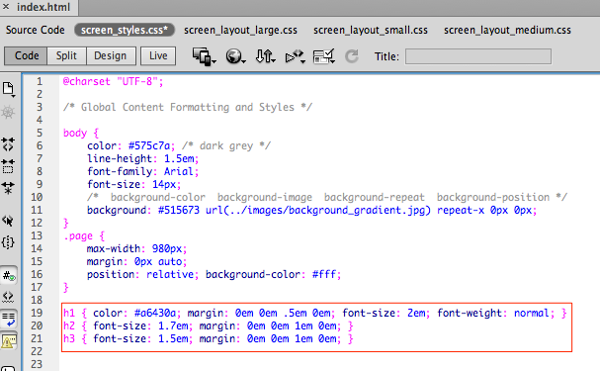

1. Save and preview on a browser.

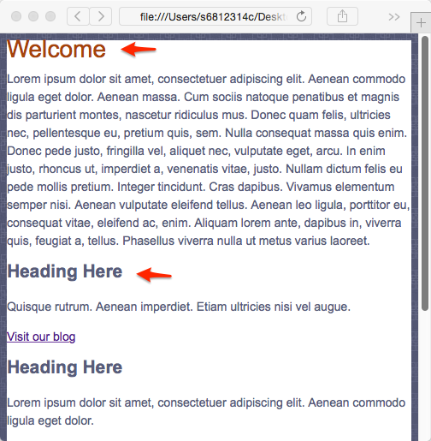

1. Screen_styles.css - Add the following styles for paragraph and link anchor:

p { margin: 0px 0px .75em 0px; }

a { color: #de9000; }

a:hover { color: #009eff; }

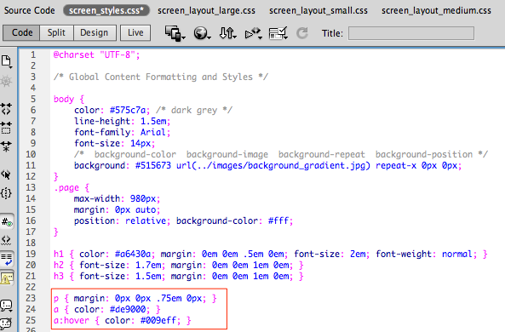

1. Save and preview on a browser.

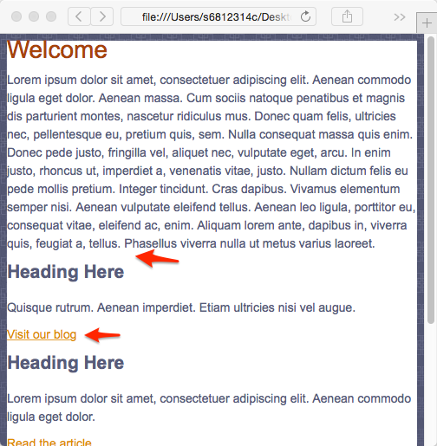 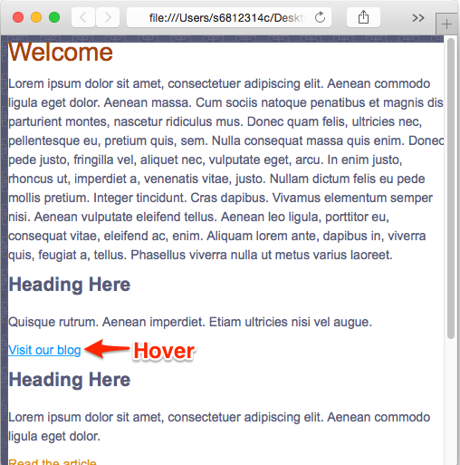

1. Screen_styles.css - Add the following styles for footer:

footer { font-size: .85em; color: #9ba0bd; background-color: #515673; padding: 10px 10px 10px 0px; }

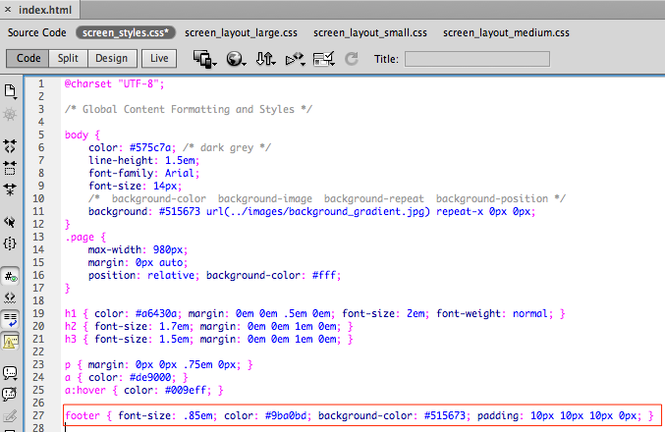

1. Save and preview on a browser.

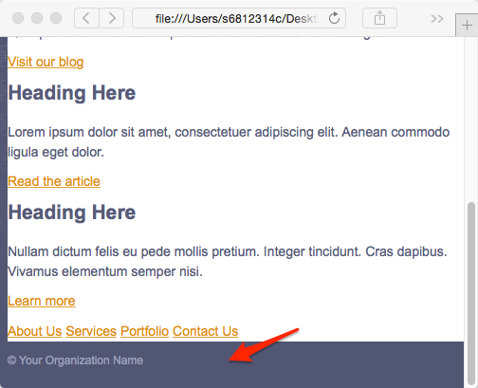

1. Index.html – Add a new class “cta” to the anchor link for the promo sections:

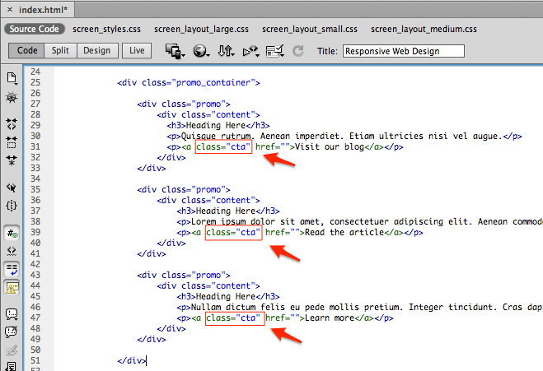

1. Screen_styles.css - Add the following styles for this new class of anchor link:

a.cta {

text-transform: uppercase;

font-size: .9em;

font-weight: bold;

text-decoration: none;

margin: .5em 0 0 0;

padding: 0px 12px 0px 0px;

background: url(../images/cta_arrow.png) no-repeat right 0px;

}

a.cta:hover { background-position: right -50px; }

A technique to shift the background arrow graphic is used here:

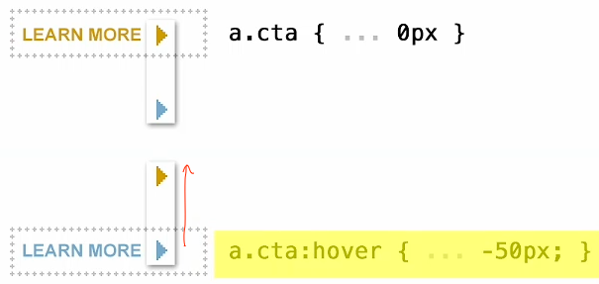

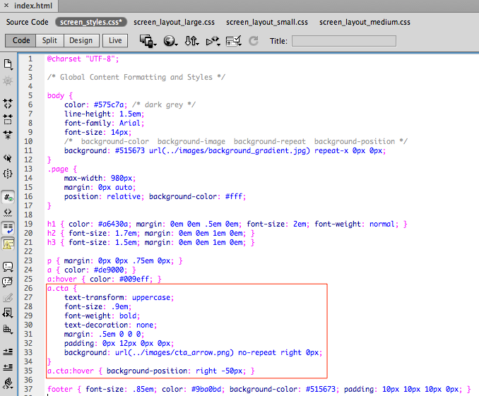

1. Save and preview on a browser.

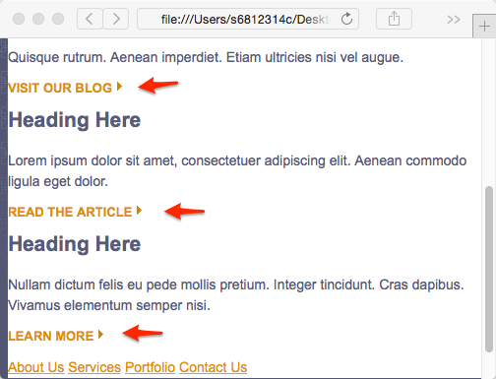 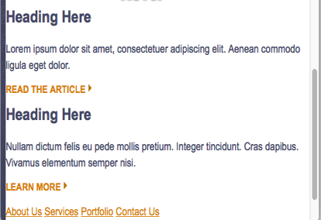

1. Screen_styles.css - Add the following styles for header h3 and paragraph in promo sections:

.promo h3 { font-size: 1.1em; margin: 0; }

.promo p { line-height: 1.2em; font-size: .9em; margin-bottom: .5em; }

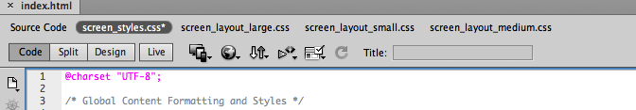

:

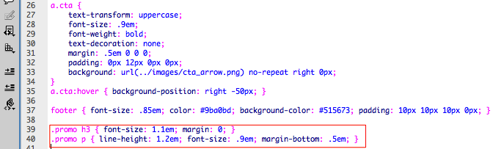

1. Save and preview on a browser.

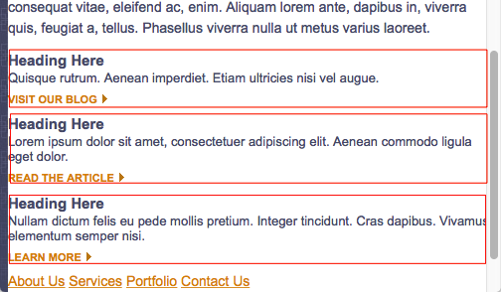

1. Index.html – Add new classes “one”, “two” and “three” to the promo sections:

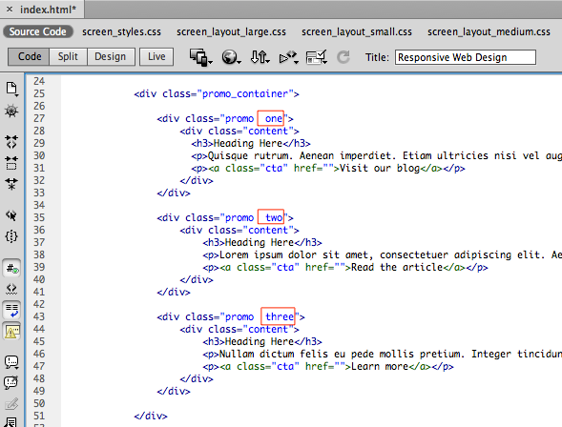

1. Screen_styles.css - Add the following styles to these new classes to add background images:

.promo { background-repeat: no-repeat; /* Apply to promo one, two and three */}

.promo.one { background-image: url(../images/promo_1.jpg); }

.promo.two { background-image: url(../images/promo_2.jpg); }

.promo.three { background-image: url(../images/promo_3.jpg); }

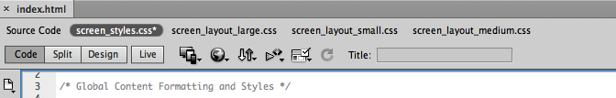

:

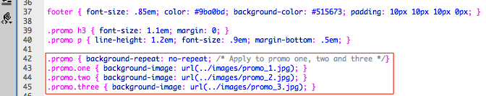

1. Save and preview on a browser. Notice that the images and the texts are overlapping. This will be address in the individual layout style sheets later.

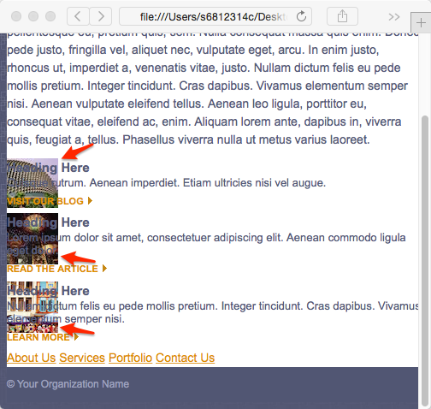

**Add styles for default large screen (screen_layout_large.css)**

Next we will be adding CSS rules applicable for the default large screen:

1. Screen_layout_large.css - Add the following styles for body, header and logo:

body { margin: 0px; padding: 0px; }

header {

height: 275px;

background: url(../images/banner_large.jpg) no-repeat right 0px;

}

header a.logo {

display: block;

position: absolute;

background-position: 0px 0px;

background-repeat: no-repeat;

}

header a.logo {

width: 200px;

height: 85px;

top: 28px;

right: 30px;

background-image: url(../images/logo_large.png);

}

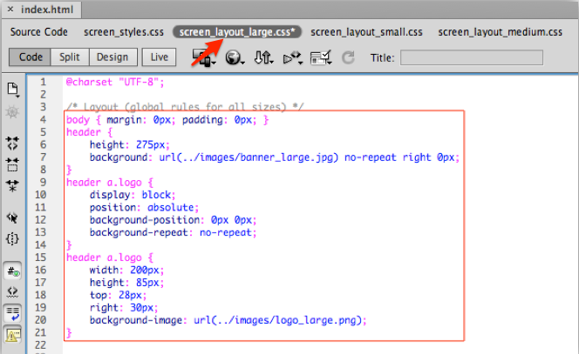

1. Save and preview on a browser and resize the window to see the effect of the CSS:

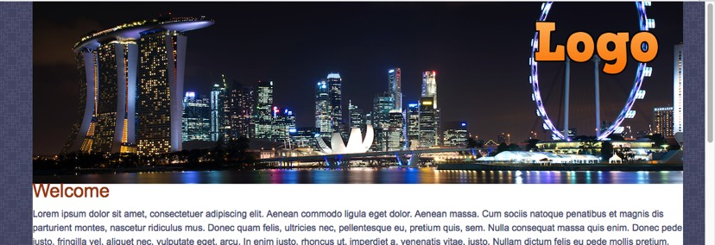

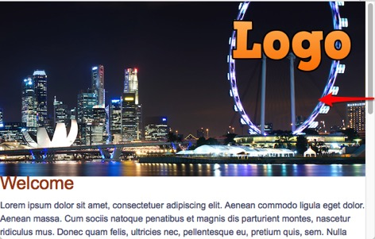

1. Screen_layout_large.css - Add the following styles for article:

article { padding: 60px 20px 10px 20px; }

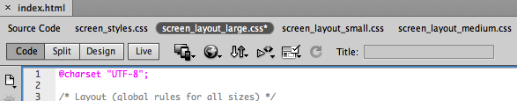

:

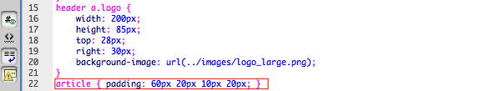

1. Save and preview on a browser.

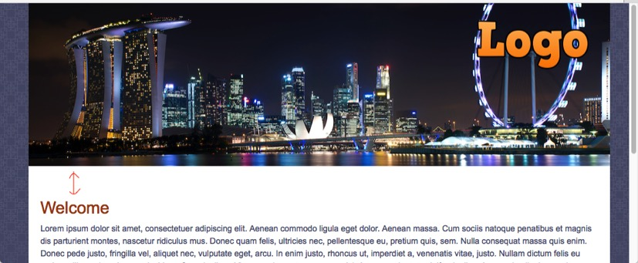

1. Screen_layout_large.css - Add the following styles for the promo sections:

.promo_container { padding: 0px 0px 15px 20px; }

.promo_container .promo {

width: 33%;

float: left;

background-position: 0px 3px;

}

.promo_container .promo .content { padding: 0px 30px 0px 70px; }

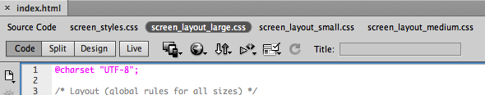

:

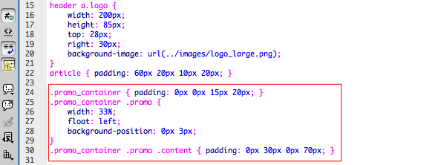

1. Save and preview on a browser.

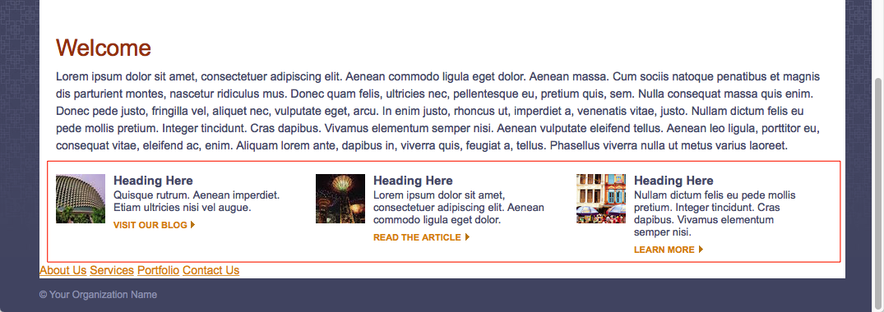

Next, we will be targeting the navigation menu that currently is right at the bottom, just before the footer.

1. Screen_style.css - Add the following styles for navigation:

nav a {

color: #f5a06e;

text-transform: uppercase;

text-decoration: none;

display: inline-block;

font-weight: bold;

font-size: .9em;

}

nav a:hover { color: #fff; }

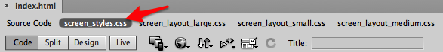

:

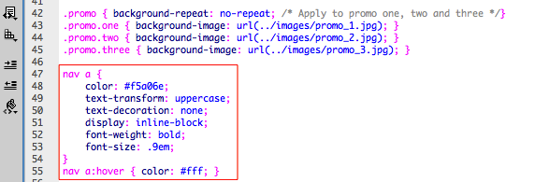

1. Save and preview on a browser. Try hovering over the links.

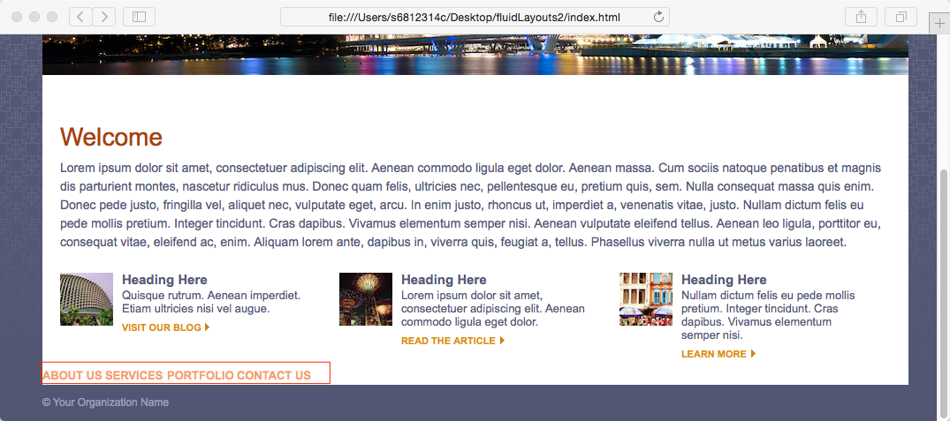

1. Screen_layout_large.css - Add the following styles for the navigation menu:

nav {

width: 100%;

display: block;

position: absolute;

background-color: #a6430a;

}

nav { top: 275px; }

nav a { margin: 12px 0px 10px 20px; }

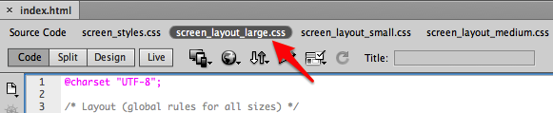

:

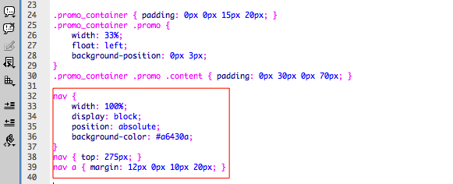

1. Save and preview on a browser. Notice that the promo sections are now outside the main container as a results of them being “float”.

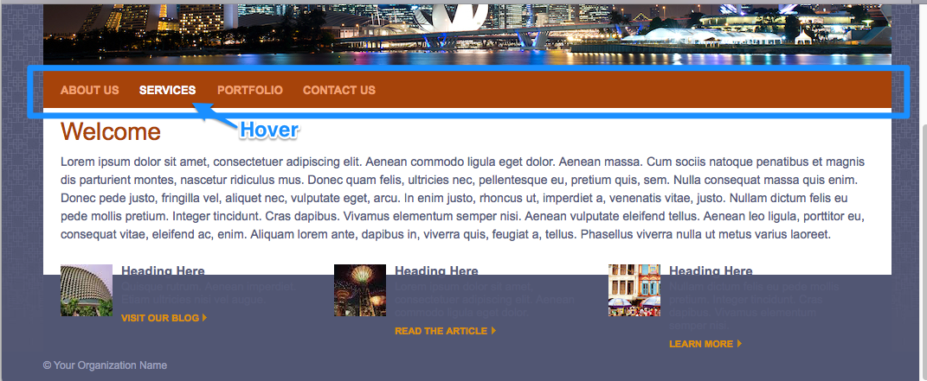

**Fix the floating error**

1. Index.html – Add a new DIV just below the promo sections but inside the promo_container:

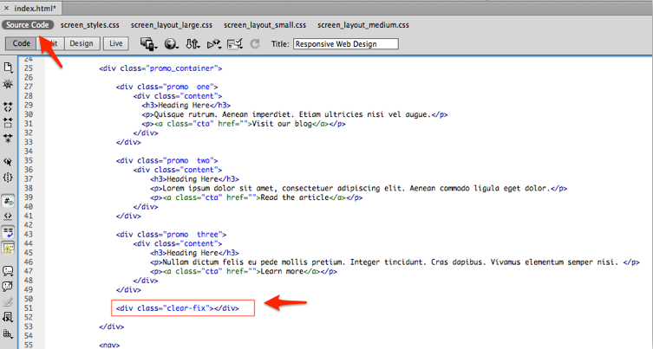

1. Screen_style.css - Add the following styles for .clear-fix:

.clear-fix { clear: both; line-height: 1px; }

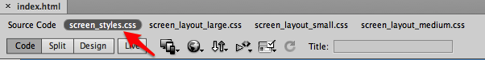

:

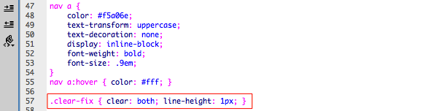

1. Save and preview on a browser. The styles for large screen are completed. Next, we will move on to styles for medium follows by small screen.

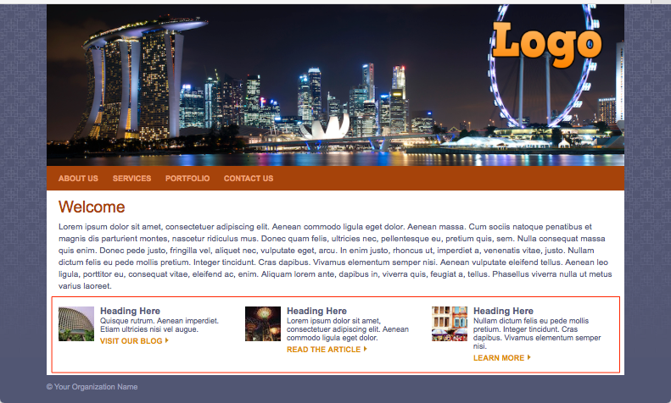

**Add Styles for Medium Screen Layout**

1. Screen_layout_medium.css - Add the following styles for header and logo:

header {

height: 200px;

background: url(../images/banner_medium.jpg) no-repeat 90% 0px;

}

header a.logo {

width: 170px; height: 70px;

top: 20px; right: 20px;

background-image: url(../images/logo_medium.png);

}

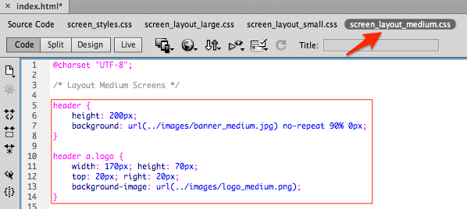

1. Save and preview on a browser. Resize the browser till below 800px in width:

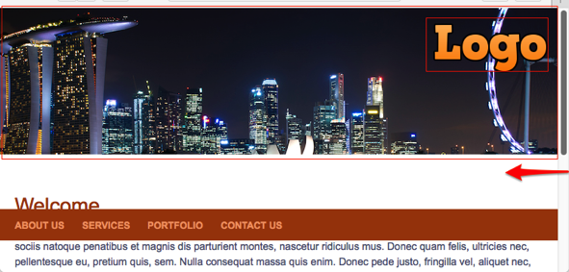

1. Screen_layout_medium.css - Add the following styles for header h1 to h3:

nav { top: 200px; }

nav a { margin-right: 20px; }

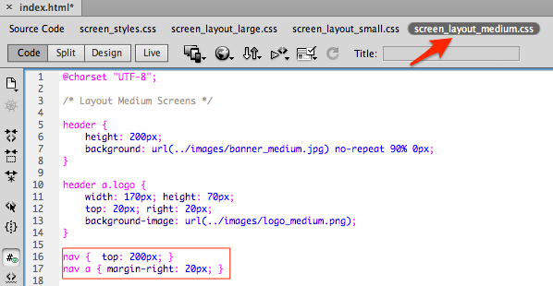

1. Save and preview on a browser.

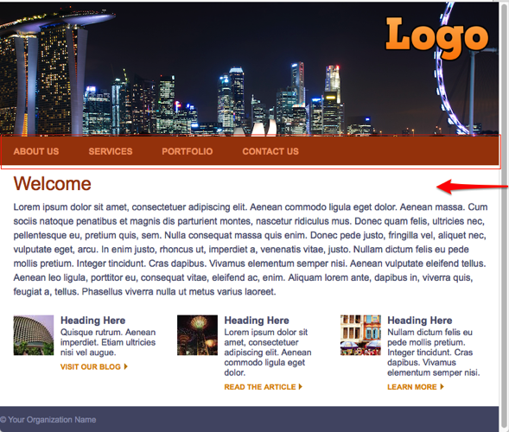

1. Screen_layout_medium.css - Add the following styles for promo sections to move the title and texts below the images:

.promo_container { padding: 0px 20px 15px 20px; }

.promo_container .promo { background-position: 0px 0px; }

.promo_container .promo .content { padding: 70px 30px 0px 0px; }

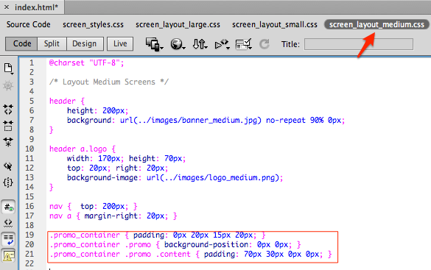

1. Save and preview on a browser.

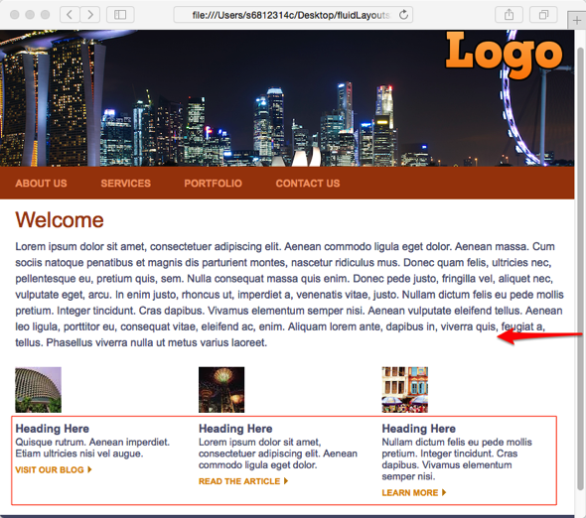

**Add Styles for Small Screen Layout**

1. Screen_layout_small.css - Add the following styles for header and logo:

header {

height: 75px;

background: url(../images/banner_small.jpg) no-repeat right 0px;

}

header a.logo {

width: 105px; height: 40px;

top: 16px; right: 15px;

background-image: url(../images/logo_small.png);

}

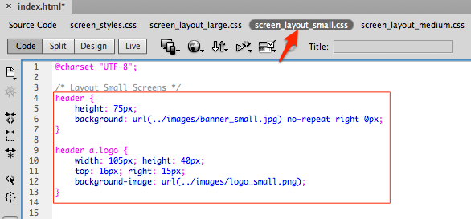

1. Save and preview on a browser.

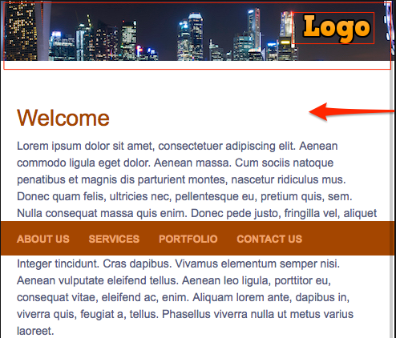

1. Screen_layout_small.css - Add the following styles for article to move it upwards:

article { padding: 20px 20px 10px 20px; }

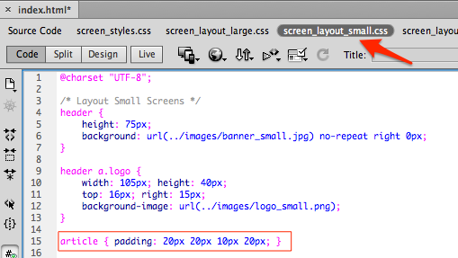

1. Save and preview on a browser.

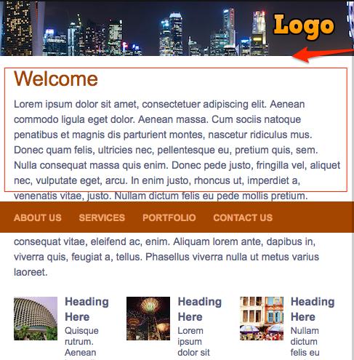

1. Screen_layout_small.css - Add the following styles for navigation menu:

nav {

display: block;

position: static;

padding: 10px 0px 10px 0px;

background-color: #515673;

}

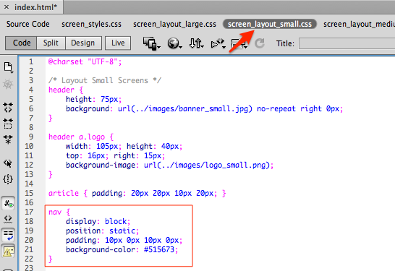

1. Save and preview on a browser.

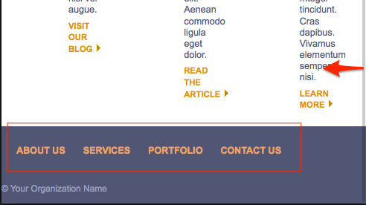

1. Screen_layout_small.css - Add the following styles for navigation menu to make it more suitable for mobile devices:

nav a {

color: #a6abc5;

display: block;

margin: 15px;

padding: 9px;

border: 1px solid #a6abc5;

background: url(../images/mobile_link_arrow.png) no-repeat right center;

-webkit-border-radius: 12px;

-moz-border-radius: 12px;

border-radius: 12px;

}

nav a:hover { color: #fff; background-color: rgba(255,255,255,.15); }

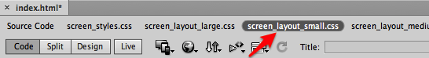

:

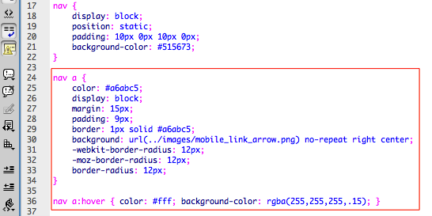

1. Save and preview on a browser.

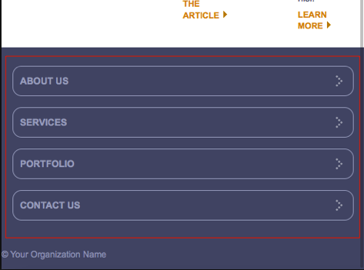

1. Screen_layout_small.css - Add the following styles for promo sections:

.promo_container { padding: 0px; }

.promo_container .promo {

width: auto;

float: none;

padding: 10px 0px 0px 0px;

background-position: 20px 13px;

border-top: 1px solid #ccc;

}

.promo_container .promo .content { padding: 0px 20px 5px 90px; }

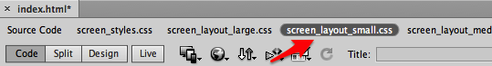

:

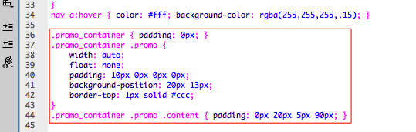

1. Save and preview on a browser.

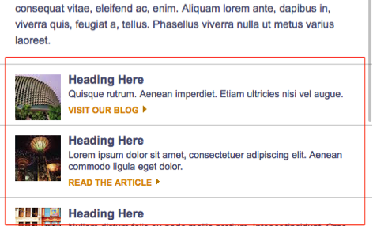

We have completed the responsive web design for this web page. Test by resizing the browser and observe the changes from large to medium, then to small screen layout.

- END -